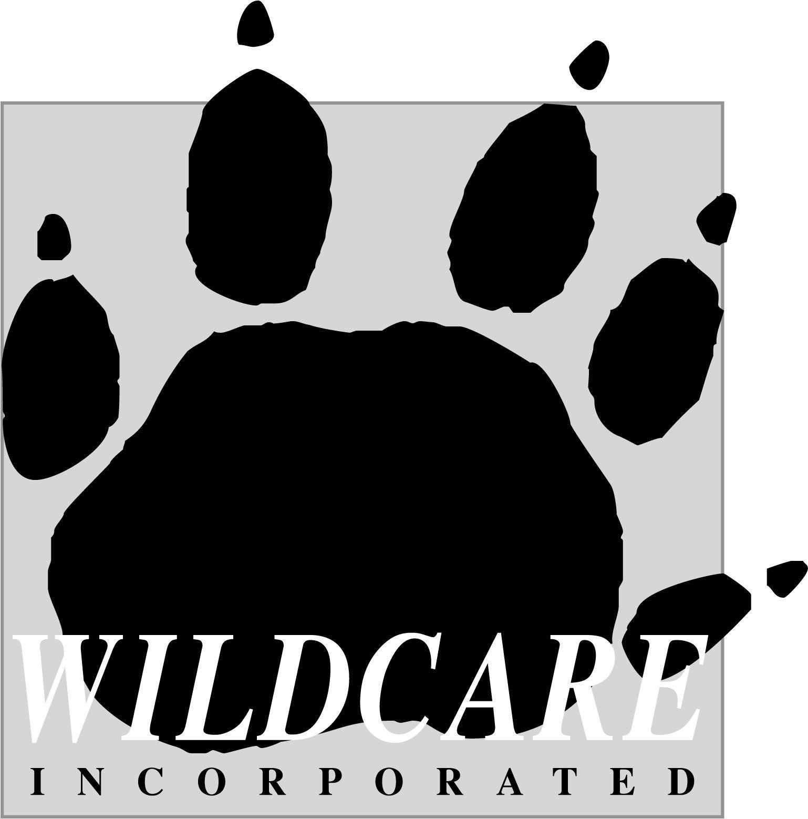
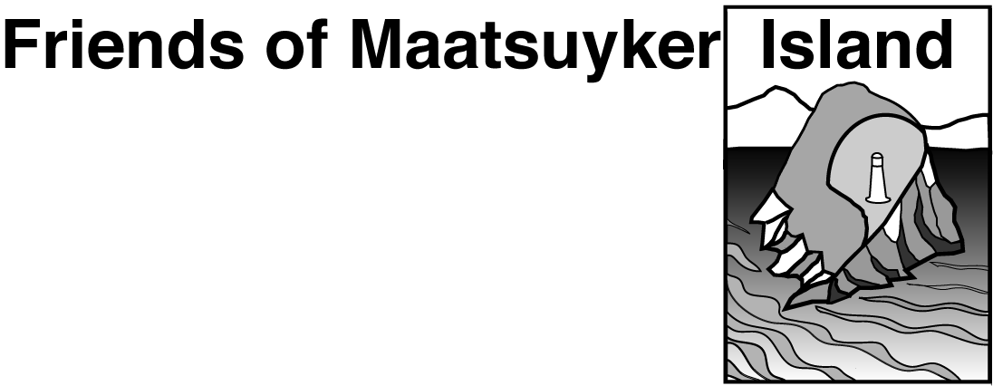


Maatsuyker Island
March 2026 on-island project work

Information for Applicants –
Weed Control/Shearwater Monitoring

Weed Control & Shearwater Monitoring Monday 9th - Thursday 19th March

This document provides information about the upcoming Friends of Maatsuyker Island - Wildcare Inc. (FOMI) and Parks and Wildlife Service (PWS) Working Bee on Maatsuyker Island in March 2026. The Maatsuyker Island Weed Control and Shearwater Monitoring programs are a continuation of the partnership between FOMI and PWS. Different aspects of the project work are funded by Landcare Tasmania, the Pennicott Foundation, Wildcare Inc. Helicopter Resources and FOMI general funds.
About Maatsuyker Island
Maatsuyker Island is approximately 180 ha and is located about 10 km off the remote south-west coast of Tasmania. The island has a rugged, steep and rocky coastline and, apart from the areas cleared for the lightstation, is covered by dense, scrubby vegetation. It is a harsh environment and the weather can be cold, wet and windy.
A lighthouse tower, lightkeepers houses and outbuildings were built in 1891 and operated until 1996 when the original light was decommissioned and replaced with an automated beacon. Apart from the European heritage values of the lightstation, Maatsuyker Island has significant natural values, primarily as a habitat for breeding seabirds and seals, and is also a site of importance to the Tasmanian Aboriginal community.
The island is managed by the PWS as a part of the South West National Park and Tasmanian Wilderness World Heritage Area. A permanent presence is maintained on the island through the PWS volunteer caretaker program. FOMI works in partnership with PWS to care for the many values of the island.

About the March 2026 Working Bee

WEED CONTROL & SHEARWATER MONITORING Working Bee

Packing, biosecurity check and briefing – Sunday 8th March from 4pm (see below)
Departure for Maatsuyker Island – Monday 9th March (weather dependant)
Return from Maatsuyker – Thursday 19th March (weather dependant)

NB: You will need to be flexible with your schedule with 1 to 3 days either side of these dates to cover the possibility of weather either delaying helicopters, or the trip needing to leave early.
It is important to be aware that all times and plans are controlled by the weather. Delays can be expected at any point – both going out to Maatsuyker Island or returning to Hobart. Helicopter travel will not be undertaken in unsafe conditions and patience will be required if bad weather is experienced. Therefore, it is important not to plan important engagements for a few days following the planned return date or at least one day prior to the planned departure date.
FOMI Project Coordinators
Marina Campbell: wildcaremaatsuyker@gmail.com (Weed Control Program)
Sheryl Hamilton: wildcaremaatsuyker@gmail.com (Shearwater Monitoring Program)

PWS Volunteer Caretakers on the island – Michelle and Duncan
PWS Rangers – Jennifer Mudge and Brett Knowles

Works Program
Weed Control program: We will undertake follow-up control and survey for Blackberry, Montbretia, Hebe elliptica and Californian Thistle. Sites will be revisited, monitored and, if necessary, treated by cut and paint herbicide application, hand pulling or digging.
Shearwater Monitoring program: You may be involved for 1 or 2 days scribing data for the shearwater burrow occupancy monitoring project. At this time of year, we will be recording whether there is a short-tailed shearwater chick in each of the study burrows.
Tasks will be allotted and supervised by the Project Coordinator/s. Certain tasks may require specific competencies (e.g. herbicide preparation) and only those with evidence of these competencies will be allotted these tasks. Other tasks may require some experience or on-site instruction. Depending on your skill set, you will need to be flexible to help where required and assist with any of the above projects. Tasks may also include assisting the PWS Volunteer Caretakers as well as maintaining the historic haulage way by removing overgrown vegetation.
Working hours will be flexible depending on conditions but generally from approximately 8.30 am to approximately 5 pm, with lunch and other breaks as required.

Fitness requirements of participants
The weather on Maatsuyker Island can be windy, wet and cold, but can also be hot. Participants need to be able to cope with working in these conditions.
It is also important that Working Bee participants have the ability to work within a close-knit team under, often, trying physical conditions.
The Weed Control and Shearwater Monitoring work can be strenuous in difficult weather conditions. As a result, the selection of volunteers for the Working Bee is targeted towards applicants with a good level of fitness and the ability to work in challenging conditions which includes uneven ground and thick vegetation.

Access to ‘non work’ areas

Maatsuyker Island is an important breeding area for many seabird and seal species. Seabird breeding sites cover large parts of the island and the breeding season will be underway during the Working Bee time-period. Due to the breeding seabirds as well as the island’s steep and rugged topography, access to areas outside the nominated work sites is restricted. There are also restricted areas within the lightstation. Access restrictions will be discussed in detail during briefings.
Briefings
Volunteers will receive briefings regarding safety considerations for the Working Bee. There will also be specific briefings at different stages, e.g. safety with helicopters.
There will be a compulsory, initial briefing held in Hobart (with a remote meeting option) approximately 2 weeks prior to the Working Bee. The biosecurity preparation and JRAs (Job Risk Analyses) will be discussed and signed at this time. Briefing date and location to be advised.
A second briefing will be conducted the afternoon/evening before leaving (from 3pm onwards) for the island which will cover all aspects of the Working Bee including important biosecurity protocols. Food supplies will be packed into lidded plastic bins and gear checked at this briefing. It is compulsory that all participants attend BOTH pre-trip briefings.
The Team will also visit the Tasmanian Herbarium. Time to be advised.

Volunteer Registration
Volunteer participants will be required to complete Department Natural Resources and Environment Tasmania (NRE Tas) online volunteer registration.
If you haven’t already done so, please complete the online registration (PC/Laptop application or Smartphone application). Please complete all relevant sections to you and select the “Friends of Maatsuyker Island” in the Additional Information section.

Insurance
This Working Bee is an official Wildcare Inc. event and all participants are required to be current 2026 Wildcare members and NRE Tas volunteers. All participants will be provided with insurance to cover:
- Public Liability (covering the volunteer against damage claims resulting from their actions)
- Personal Accident (including cover for loss of income and non-Medicare medical expenses.
Travel arrangements
Travel to Maatsuyker Island will be from Cambridge (Helicopter Company) or the PWS helicopter landing site at Ryans Point, Recherche Bay.
Volunteers leaving from Ryans Point will carpool from Hobart. Volunteers leaving from Cambridge will need to make their own arrangements to be dropped off or leave a car at the Helicopter Company. You will be provided with a helicopter schedule several days before the departure date.
Accommodation on Maatsuyker Island
The Working Bee group will have the use of two of the historic lightkeepers houses, Quarters 2 and 3. The houses have electricity and an electric fridge (solar and generator), gas stove and gas hot water. There is a shower. The houses have good beds with mattresses and pillows. Volunteers need to be prepared to share a bedroom and communal bathroom. Bring your sleeping bag, pillowcase, and sheet as there are vinyl covers on the pillows and mattresses.
Catering/food
Dinners: Dinner will be a group meal together. We will each take it in turns (with a ‘chef’ partner from the group to help) to provide for and cook one evening meal for 10-12 people (the PWS Volunteer Caretakers often join us for a meal). We will pair people up and provide more info at the briefing. Please let us know of any dietary requirements. If we are caught on the island for extra days, meals can be made up from ‘leftovers’ and extra “emergency” food we have on the island. FOMI will coordinate some communal food (e.g. milk, milk powder, tea, coffee, cooking oil, sauces, spreads) and will circulate a list of communal food prior to the trip. The cost for communal food is $50 from each Working Bee participant.
Catering and food preference details will be discussed at the first pre-trip briefing (see Briefings). Participants self-provision for breakfast, lunch and snacks.
Biosecurity Tasmanian Wilderness World Heritage Area: Aircraft Landing Authority Biosecurity Checklist
The PWS Biosecurity Checklist MUST be completed prior to our flight into the TWWHA to reduce the risk of transporting unwanted Biosecurity Risk Material (BRM) into the Tasmanian Wilderness World Heritage Area (TWWHA).
BRM includes all forms of plant and animal material, food scraps, insects, pathogens, soil, and water.Some items may be refused transportation due to biosecurity concerns.
The FOMI Team Leader/s, as the Authority Holder, are responsible for biosecurity. All baggage and equipment MUST be inspected by the Authority Holder/s prior to departure and complete the Checklist. The Checklist will be provided to working bee participants at the first briefing.
These are not listed in any particular order apart from the first dot point being critical:
- PWS Officer/FOMI Coordinator(s) have been briefed to be the designated biosecurity inspector(s) to ensure this plan is carried out. They must inspect all gear and food going to the island.
- The designated person (above) must inspect all staff/volunteer bedding, clothing and boots for seeds/dirt/insects and stored in secured bags or sealed in pest-free containers.
- Volunteer’s gear is to be thoroughly cleaned before packing and transporting to the island.
- Food and small goods are to be secured in clean containers (plastic bins will be provided at the pre briefing to pack food and gear).
- All personnel (PWS & volunteers) have clean boots that are disinfected in salt water, or a F10 or chlorine/water mix, just before boarding the helicopter.
- All non-electrical tools to be washed clean and dried the day before the trip and stored in a clean environment.
- All toolboxes are to be opened and emptied out of all seeds, soil fragments and inspected for insects /mice etc.
- Volunteers are to ensure they thoroughly clean the interior of the vehicle including taking out floor mats to wash and clean under, no later than day before transporting goods (OR – use a clean tarp inside the car to place luggage onto).
- All PWS vehicles, trailers and plant will be washed down thoroughly, allowed to dry the day before loading, on or on the day of loading but no earlier.
- All gear arriving at Ryan’s Point helipad is to be stacked on clean tarps on the ground (other than timber and fuel).
- On departure volunteers will be required to wear a different pair of socks & shoes up until we board the chopper (e.g. old sneakers are good). Volunteers will change into the socks & boots you plan to wear on the island just before boarding the chopper.

Workplace Health and Safety
The provision of a safe working environment and safe working procedures is mandatory for all works carried out by PWS. This volunteer project on Maatsuyker Island will be carried out according to all current safe-working procedures. Volunteers will be made familiar with these procedures and will be expected to adhere to them. FOMI and PWS will supply all tools and personal protective equipment required for this project.

Safety and Emergency Communication
There is a telephone in the caretaker’s residence on Maatsuyker Island and in the ‘weather office’. The phone is available for quick calls to family and for emergency use.
Phone (03) 6298 3176. There is also a radio that can be used to contact Parks. There is no mobile phone coverage. Limited data for the internet is available at Quarters 2.
First aid kits will be taken for the group but individuals should also have small personal kits. Qualified first aiders are a part of the team. Volunteers will be asked to identify if you have first aid qualifications.
All work gear will be supplied. High vis vests and safety glasses will be supplied and expected to be worn. Ear plugs will be issued for use when in vicinity of the helicopter. If you have a problem with the standard allocation of safety glasses, you will need to supply a pair that you can wear.
Volunteers will be required to complete a NRE Tas Volunteer On-line Registration. Volunteers will also be asked to read and sign the PWS Job Risk Analysis for each aspect of the working bee i.e. helicopter transport, use of chemicals (if weeding), remote area living, safe lifting. These documents will be discussed and finalised at a pre-trip briefing.

Personal Protective Equipment (PPE)
Participants will be expected to provide and wear suitable work attire while working. This includes a long sleeve shirt, trousers, sturdy boots and sunhat. In addition, volunteers will need to have warm clothing and wet weather gear for colder days. If you have any questions, please discuss these requirements with FOMI Team Leader/s before departure. We will provide suggested gear lists to Working Bee participants.
Those involved in specialist duties, such as herbicide spraying, will be provided with appropriate specialist PPE arranged beforehand. FOMI/PWS will provide the following general PPE for all participants:
- Leather and Nitrile work gloves
- High visibility vests
- Safety glasses (if you have a problem with the standard allocation of safety glasses, you will need to supply a pair that you will wear. Safety glasses are not required if wearing prescription glasses)
- First Aid supplies
- Emergency communication equipment
- Ear plugs (to be worn when in vicinity of the helicopter)
- Sunscreen
A well-equipped first aid kit will be taken for the group but individuals should also have personal kits. Volunteers will be asked to identify if they have first aid qualifications.
Packing
Baggage will be limited to 35 kg per person, including food. Working Bee participants meet (location to be notified closer to the date) the evening (from 3pm onwards) beforehand to pack the food into plastic bins and ensure all gear is thoroughly checked - as per above biosecurity protocols. All food and gear will be stored at this location overnight. You will have a small day pack on your person.
Some hints:
- do not tie separate items together
- smaller items are more flexible to pack as everything goes into plastic, sealed bins
- avoid long or fragile items projecting from bags
- all containers (e.g. plastic fish bins, bags) should be well sealed as they may not stay upright.
- your personnel clothes and gear can be in a larger backpack/bag as long as it is closed well and there are not options for bugs/vermin to access.
Dangerous goods are not to be carried on the helicopter. Thoroughly check your baggage for freeloaders: make sure there are no insects, spiders, mice, soil or plant seeds hiding in your containers.
Please refer to biosecurity to ensure you are not bringing in pest, seeds etc.
What to take – (bushwalking gear)
- day pack
- sleeping bag, sheet for bed, pillowcase
- toiletries & any personal medications required
- wet weather gear - trousers and coat, gaiters (bush walking gear – good for pushing through thick and wet vegetation)
- clothes (warm and also light), sunhat, beanie
- water bottle
- watch, torch, camera, binoculars, batteries
- boots/gumboots
- indoor shoes/slippers – Ugg Boots or crocs are good for inside the house
- small personal first aid kit
- book (for the possible wet/windy day)

_____________
Please click on the link below to go to the application form for the working bee.
Link to Application Form

