Mitigating risks to Live-bearing Seastar Populations
SNSEA000008 (Jan 2025-June 2026)
This report evaluates the effectiveness of invasive species removal (Pacific oysters and porcelain crabs) in improving population outcomes for the endangered live-bearing sea star (P. vivipara). We assessed changes in sea star density, invasive species abundance, and broader community responses across 5 removal and 3 control sites Although 5 sites were classified as removal sites, intensive removal and analysis focused on 3 primary sites (Lumeah Point, Woodbridge, and Susans Bay), where invasive species occurred within live bearing sea star habitat. Monitoring comprised 4 survey rounds (2 pre- and 2 post-removal) across 7 sites with an extra control site added in Year 2.
Key findings:
- Invasive species removal increased local live-bearing sea star densities but did not offset broader, system-wide declines, indicating that additional environmental drivers are influencing populations.
- Removal sites showed relative increases in live bearing 1.77 ind. m²sea star density compared to -0.198 ind. m controls
- Live bearing sea star populations declined across Pipeclay Lagoon, including both removal and control sites.
- ~79,270 New Zealand porcelain crabs and 1,411 kg of Pacific oysters were removed across 3 sites in sea star habitat, and an additional 78 New Zealand porcelain crabs were removed from nearby to sea star habitat at another 2 sites.
- Native species richness declined before and after removals, but less so at removal sites
- Native species abundances declined through time both removal and control sites.
- Species community responses varied among sites, with small overall compositional changes, substantial overlap between treatments, and increased variability at removal sites following intervention.
- Volunteer engagement and media outputs/outreach activities substantially increased throughout the project.

Project recommendations
This project demonstrated removals of New Zealand porcelain crabs and Pacific oysters produced clear benefits for the live bearing sea star across 3 high-priority removal sites, supporting its value as a key conservation intervention strategy. However, the results showed that removals of these invasive species showed only marginally non-significant declines in New Zealand porcelain crab abundances and Pacific oysters in removal sites as compared to control sites, suggesting that 2 years of volunteer-based removal efforts may be insufficient to ensure live bearing sea star populations recovery in the long-term. Environmental variability and site-specific conditions are likely important factors influencing these results.
Throughout the project, monitoring revealed substantial declines in live bearing sea star densities at sites within Pipeclay Lagoon. At the removal site, Lumeah Point, declines were first evident during the May–June 2025 surveys and persisted through November–December 2025 and into April–June 2026. A similar pattern was observed at the control site in southwest Pipeclay Lagoon, where densities decreased between the November–December 2025 and April–June 2026 surveys (see Report 3 for full details). These consistent downward trends indicate a concerning reduction in population size across these sites. Continued monitoring of these populations and environmental conditions within Pipeclay Lagoon, is critical. Active management interventions may also be required to prevent localised extinctions.
To strengthen conservation outcomes, several management actions are recommended:
- Expand invasive species removal efforts to additional sites (e.g. Lewisham or the Pittwater Estuary) to increase spatial coverage, particularly in areas supporting small populations of live bearing sea stars.
- Maintain ongoing removal at all current sites, including those with lower invasive species densities or sites located adjacent to, or outside, core habitat areas (e.g. Tessellated Pavement and Fortescue Bay), to prevent population build-up of invasive species.
- Maintain long-term population monitoring of the endangered live-bearing sea star, including Pipeclay Lagoon populations and environmental conditions and prepare an intervention strategy
- Implement sustained, long-term control strategies to reduce numbers of invasive species.
- Monitor the longer-term ecological effects of invasive species removal on broader native biodiversity.

  - Removal effort and implementation
To evaluate the effectiveness of the removal events we assessed the number of days and volunteers, amounts of invasive species removed and the percentage of live bearing sea star habitat cleared.
Table 1. Overview of sampling effort and removal outcomes at each site, including the total number of New Zealand porcelain crabs and Pacific oysters removed, number of sampling days and volunteers, and the area cleared of invasive species, total sea star habitat area, and the percentage of sea star habitat cleared.
 |  | Removal sites
Metric |  | Lumeah Point | Woodbridge | Susans Bay | Tessellated Pavement | Fortescue Bay
Number of removal days |  | 10 | 6 | 5 | 3 | 3
Number of volunteers |  | 61 | 214 | 62 | 19 | 13
NZ porcelain crab (counts) |  | 16080 | 24240 | 38950 | 70* | 8*
Pacific oyster (counts) |  | 23760 | 4280 | 220* | 0 | 1*
Area cleared of invasive species (m²) |  | 818 | 787 | 141 | NR | NR
Total sea star habitat area (m²) |  | 212 | 230 | 108 | 0 | 0
Percentage of sea star habitat cleared (%) |  | 100 | 100 | 100 | 0 | 0

Note: * indicate removals in areas nearby to sea star habitat. NR = not recorded.
Invasive species removals
Across the project, the number of invasive species removal days exceeded original targets and was adaptively distributed across the five sites to maximise conservation outcomes (Table 1). A total of approximately 79,270 New Zealand porcelain crabs and 1,400 kg of Pacific oysters (equivalent to ~28,040 individuals, assuming an average weight of ~50 g per oyster) were removed over 27 days, with effort concentrated at high-density sites including Lumeah Point, Woodbridge, and Susans Bay.
Removal intensity varied among locations, reflecting differences in invasive species abundance and site accessibility. Additional low-intensity removals were conducted at Tessellated Pavement and Fortescue Bay, where invasive species occurred adjacent to-but not within live bearing sea star habitat. Similar low-intensity removal was also undertaken at Susans Bay, where Pacific oysters were present at the site but not within live-bearing sea star habitat.
In total, volunteers and IMAS staff removed invasive species from 100% of live-bearing sea star habitat across the 3 priority sites where invasions were detected. This was not 100% of the invasive species in these areas.
Volunteer engagement
Volunteer participation increased markedly over the course of the project with 256 individuals contributing overall (~256% increase between Year 1 and Year 2). The increase was driven by expanded engagement, media exposure and increased removal opportunities with partner organisations.
Volunteers contributed primarily to invasive species removal events, receiving training in species identification, handling techniques, and habitat protection. This resulted in significant expansion of community capacity for conservation action. Monitoring activities were limited to 2 experienced community groups due to technical requirements.
Strong partnerships were established with community organisations and local councils, supporting ongoing stewardship beyond the life of the project.
Media outputs and outreach activities
The project delivered 29 media outputs and outreach activies, including 16 social media posts, 6 media features, and 7 outreach events (presentations, field visits, and community meetings).
These activities substantially increased public awareness of the endangered live-bearing sea star, its conservation status, and the impacts of invasive species. Outreach initiatives improved understanding of the species’ vulnerability and the broader pressures affecting intertidal ecosystems, including habitat degradation and introduced species. Engagement activities also strengthened relationships with key stakeholders, including local community groups and members, managers, and practitioners, fostering greater collaboration and shared ownership of conservation outcomes. These activities also strengthened relationships with stakeholders and supported behaviour change by building skills and knowledge in conservation practices.

  - Effects of invasive species removals on target species
The effectiveness of removal events on target species was assessed using live bearing sea star density, New Zealand porcelain crab abundance, Pacific oyster cover. The analysis focused on 3 removal sites (Susans Bay, Lumeah Point, Woodbridge) and 3 control sites (Bambra Reef, SW Pipeclay, Lewisham), (Figure 1, Table 2). The additional sites Tessellated Pavement and Fortescue were classified as removal sites, but invasive species were located adjacent to live bearing sea star habitat, resulting in minimal direct treatment effects.
Table 2. Overview of results showing mean (± SE) and percentage change before and after invasive species removal across Years 1 and 2 for live-bearing sea star density, New Zealand porcelain crab abundance, Pacific oyster cover, faunal species richness, and faunal species abundance (excluding live-bearing sea stars, New Zealand porcelain crabs) at each of the removal and control sites.
 | Removal sites |  |  |  |  | Control sites
Metric | Lumeah Point | Woodbridge | Susans Bay | Tessellated Pavement | Fortescue Bay | Bambra Reef | Southwest Pipeclay | Lewisham
Live-bearing sea star  (ind m⁻²) | 0.12 (±0.13)  +226.00% | 0.03 (±0.03)  +65.2% | 5.33 (±4.17)  +93.60% | 0.16 (±0.08)  +93.60% | 0.08 (±0.08)  +58.10% | 0.58 (±2.96)  +6.94% | -0.75 (±0.42)  -75.20% | 0.1 (±0.16)  +45.90%
NZ porcelain crab (abundance) | -4.56 (±1.62)  -57.72% | -15.45 (±6.22)  -36.67% | -48.70 (±12.66)  -52.43% | 0 (0)  0% | 0 (0)  0% | -8.36 (±6.94) | 0.16 (±1.90)  +6.15% | -4.98 (±5.07)  -18.69%
Pacific oyster (cover) | -0.03 (±0.02)  -33.39% | -0.01 (±0.01)  -42.53% | 0 (0)  0% | 0 (0)  0% | 0 (0)  0% | 0.01 (±0.01)  +34.38% | 0.01 (±0.01)  +26.22% | 0 (0)  0%

Response of live bearing sea star
Live bearing sea star density showed a significant positive response to removal. Across the 3 removal sites density increased by +1.04 ind. m⁻², while declining at control sites by −0.44 ind. m⁻², resulting in a highly significant interaction.
This divergence indicates that invasive species removal altered ecological conditions in a manner that favoured sea star populations, potentially through release from competition for space previously occupied by Pacific oysters and porcelain crabs.
Response of New Zealand porcelain crabs and Pacific oyster
In contrast, the 2 removed taxa exhibited weaker and less consistent responses. Pacific oyster cover declined at removal sites (Δ ≈ −0.014), while remaining relatively stable at control sites (Δ ≈ +0.001), suggesting a directional but variable reduction between sites.
Similarly, porcelain crab density declined at both removal and control sites, with a larger decline at removal sites (Δ ≈ −15 ind. m⁻²) compared to controls (Δ ≈ −2 ind. m⁻²), also suggesting a directional but variable reduction between sites. A significant year effect for porcelain crabs indicates strong interannual variability influencing populations across all sites.
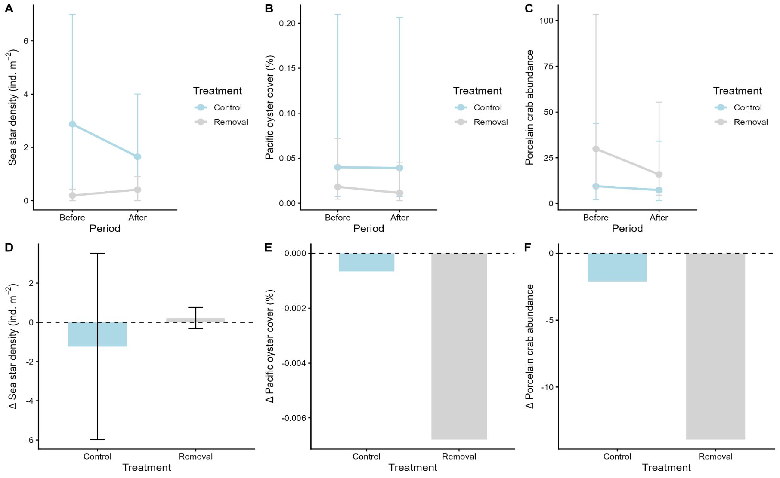
Figure 1. Changes in live-bearing sea star (P. vivipara) density, Pacific oyster (M. gigas) cover, and New Zealand porcelain crab (P. elongatus) abundance in response to invasive species removal. Panels (A–C) show mean values (95% ± CI) before and after treatment for control (blue) and removal (grey) sites for (A) sea star density (ind. m⁻²), (B) Pacific oyster cover (%), and (C) porcelain crab abundance. Panels (D–F) show the corresponding change (Δ) between before and after periods for (D) sea star density, (E) Pacific oyster cover, and (F) porcelain crab abundance across treatments. This figure shows clear divergence between treatments with sea star density increasing at removal sites while declining at control sites.
  - Effects of invasive species removals on other native species
To evaluate the effects of the removal events on native biodiversity we assessed the richness and abundances of other native invertebrate species excluding live bearing sea star.
Table 3. Overview of results showing mean (± SE) and percentage change before and after invasive species removal across Years 1 and 2 richness and abundance of native invertebrates (excluding live-bearing sea stars, New Zealand porcelain crabs, and Pacific oysters) at each of the removal and control sites.
 | Removal sites |  |  |  |  | Control sites
Metric | Lumeah Point | Woodbridge | Susans Bay | Tessellated Pavement | Fortescue Bay | Bambra Reef | Southwest Pipeclay | Lewisham
Species richness | -0.78 (±0.52)  -12.54% | -0.06 (±0.46)  -0.82% | -1.10 (±0.55)  -18.33% | 0.22 (±0.48)  +2.70% | -0.54 (±0.61)  -6.73% | -2.02 (±0.49)  -22.00% | -1.60 (±0.60)  -21.11% | -0.78 (±0.58)  -12.75%
Species abundance | -20.82 (±11.75)  -35.42% | -4.90 (±4.93)  -10.48% | -12.72 (±4.80)  -35.35% | -7.86 (±20.38)  -6.77% | 2.54 (±6.46)  +5.14% | -21.46 (±10.35)  -23.93% | -8.94 (±5.78)  -23.92% | -8.14 (±4.91)  -25.76%

Species richness
Species richness declined over time at both the removal and control sites; however, declines were greater at control sites (Δ = −1.77) than at removal sites (Δ = −0.64), (Figure 3, Table 3). This indicates that removal of Pacific oysters and New Zealand porcelain crabs moderated, but did not reverse, seasonal declines in diversity. While removal may have buffered losses in richness—potentially by maintaining habitat or reducing competition—it did not result in overall community recovery within the study period.
Species abundances
Total invertebrate abundance varied with treatment and time, but no treatment × period interaction was detected (Figure 3, Table 3). Temporal changes in invertebrate abundance were therefore consistent across removal and control sites, suggesting that broader environmental factors, rather than invasive species removal, were the primary drivers of abundance patterns.
Community composition
Community composition was influenced by removal, although effects were small (Figure 4, Table 4). Despite a significant interaction between treatment and period, ordination analyses showed substantial overlap among groups, indicating only minor compositional shifts across multiple taxa. Responses to invasive species removals varied among sites. Post-treatment, removal sites exhibited increased variability in community composition relative to control sites, whereas no differences were evident prior to removal.
Overall, invasive species removal did not produce a uniform change in native community composition. Instead, it increased variability among sites, consistent with a disturbance response in which removal creates opportunities for divergent community trajectories rather than a single, predictable outcome.

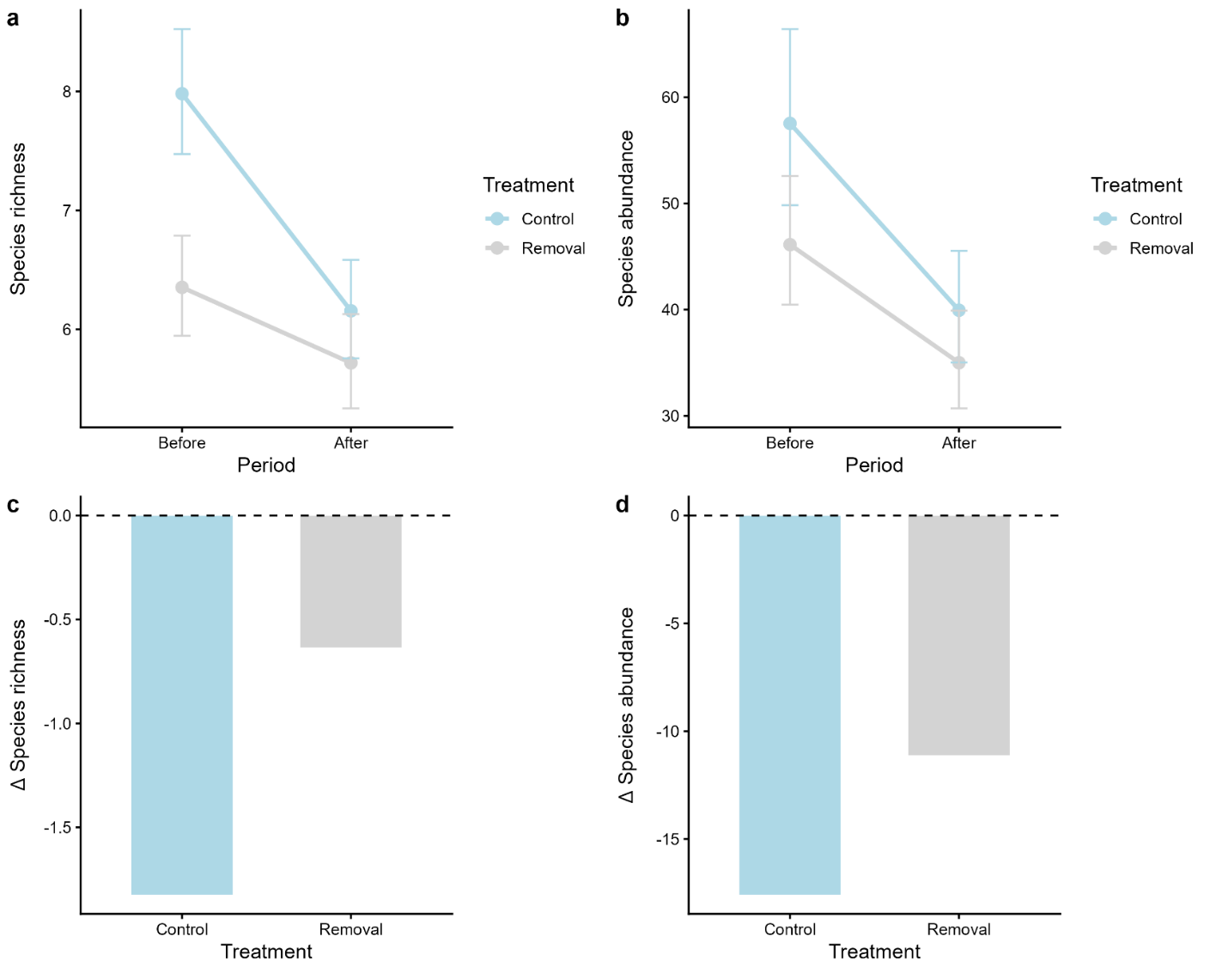
Figure 2. Changes in native species richness and abundances in response to invasive species removal. Panels (A–C) show mean values (± 95% CI) before and after treatment for control (blue) and removal (grey) sites for (A) species richness, (B) species abundances. Panels (C–D) show the corresponding change (Δ) between before and after periods for (C) species richness, (D) species abundance across treatments.

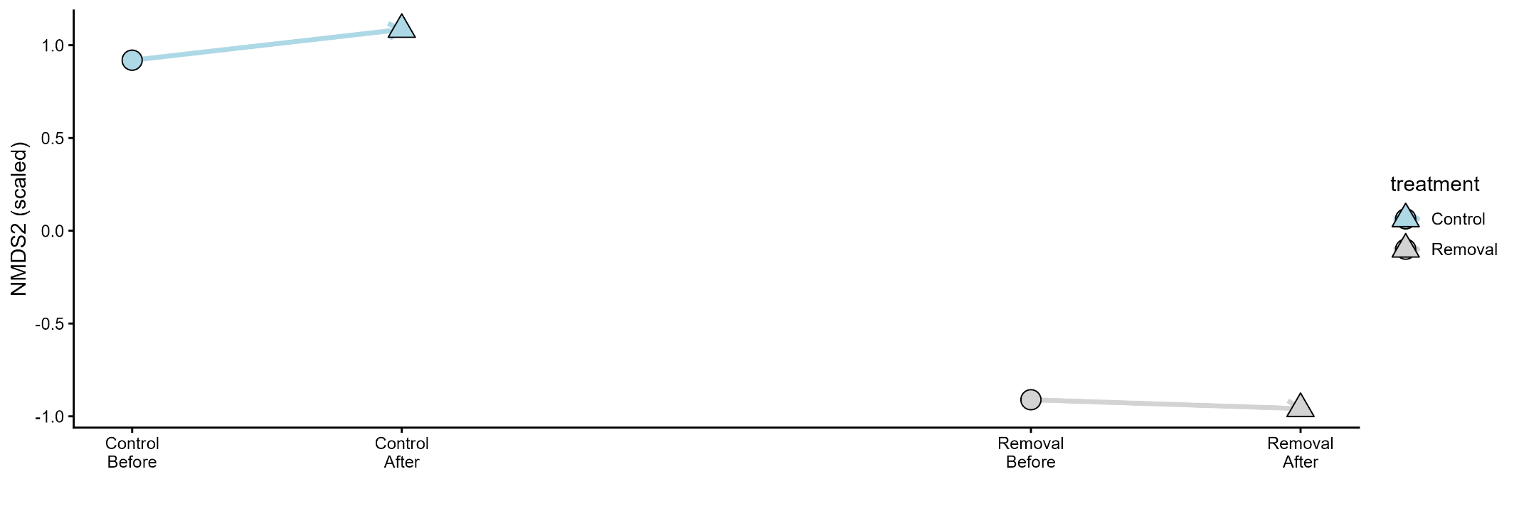

Figure 3. Non-metric multidimensional scaling (NMDS) ordination showing changes in community composition before and after treatment for control (blue) and removal (grey) sites. Points represent centroids of community composition for each treatment–period combination, with circles indicating “before” and triangles indicating “after”. Trajectories illustrate the direction and magnitude of compositional change over time within each treatment.

Table 4: Results of analyses testing the effects of treatment (removal vs control), period (before vs after), and year on response variables. Test statistics are shown as χ² values with associated degrees of freedom (df) and p-values.

Response variable | Factor | χ² | df | p-value
Sea star density | Treatment | 1.17 | 1 | 0.279
 | Period | 3.58 | 1 | 0.059
 | Year | 0.69 | 1 | 0.404
 | Treatment × Period | 9.35 | 1 | 0.002
Pacific oyster cover | Treatment | 0.51 | 1 | 0.474
 | Period | 0.01 | 1 | 0.932
 | Year | 4.54 | 1 | 0.033
 | Treatment × Period | 2.72 | 1 | 0.099
Porcelain crab density | Treatment | 1.30 | 1 | 0.253
 | Period | 1.95 | 1 | 0.163
 | Year | 36.19 | 1 | <0.001
 | Treatment × Period | 3.04 | 1 | 0.081
Species richness | Treatment | 32.02 | 1 | <0.001
 | Period | 22.94 | 1 | <0.001
 | Year | 3.70 | 1 | 0.055
 | Treatment × Period | 3.57 | 1 | 0.059
Total abundance | Treatment | 6.65 | 1 | 0.010
 | Period | 21.78 | 1 | <0.001
 | Year | 7.10 | 1 | 0.008
 | Treatment × Period | 0.42 | 1 | 0.519

Table 5: Results of analyses testing the effects of treatment (removal vs control), period (before vs after), and year on community composition and individual species. Test statistics are shown as χ² values with associated degrees of freedom (df) and p-values.
Factor | Residual df | df | Deviance | p-value
Intercept | 817 | – | – | –
Treatment | 816 | 1 | 1266.1 | <0.001
Period | 815 | 1 | 292.4 | <0.001
Year | 814 | 1 | 380.4 | <0.001
Treatment × Period | 813 | 1 | 148.5 | <0.001

Species | Treatment | Period | Year | Treatment × Period
Actinia tenebrosa | 0.026 | 1.000 | 1.000 | 1.000
Alaba monile | 0.179 | 1.000 | 0.158 | 1.000
Allostichaster polyplax | 0.376 | 1.000 | 0.316 | 0.968
Amphipholis squamata | 0.920 | 1.000 | 1.000 | 0.991
Austrocochlea constricta | 0.001 | 1.000 | 1.000 | 1.000
Bembicium nanum | 0.001 | 1.000 | 1.000 | 0.967
Brachidontes erosus | 0.001 | 1.000 | 1.000 | 1.000
Cacozeliana granarium | 0.009 | 1.000 | 0.082 | 1.000
Catomerus polymerus | 0.001 | 1.000 | 0.742 | 1.000
Cellana solida | 0.001 | 0.663 | 1.000 | 1.000
Chaemosipho tasmanica | 0.007 | 1.000 | 1.000 | 1.000
Chiton glaucus | 0.004 | 1.000 | 0.001 | 1.000
Cominella lineolata | 0.001 | 1.000 | 0.839 | 1.000
Dicathais orbita | 0.005 | 0.423 | 1.000 | 0.855
Diloma concameratum | 0.001 | 1.000 | 1.000 | 1.000
Mytilus galloprovincialis | 0.001 | 1.000 | 1.000 | 1.000
Nerita atramentosa | 0.001 | 0.117 | 0.011 | 1.000
Notoacmea flammea | 0.001 | 1.000 | 0.550 | 0.344
Onchidella nigricans | 0.001 | 0.010 | 1.000 | 0.997
Oulactis muscosa | 0.001 | 1.000 | 0.207 | 0.570
Paragrapsus gaimardii | 0.001 | 0.128 | 0.297 | 1.000
Paragrapsus quadridentatus | 0.001 | 1.000 | 1.000 | 1.000
Parvulastra exigua | 0.001 | 1.000 | 1.000 | 1.000
Patelloida spp. | 0.001 | 0.900 | 1.000 | 0.955
Plaxiphora albida | 0.001 | 1.000 | 1.000 | 1.000
Phasianotrochus irisodontes | 0.029 | 1.000 | 0.002 | 1.000
Siphonaria diemenensis | 0.001 | 0.720 | 1.000 | 1.000
Sypharochiton pelliserpentis | 0.001 | 0.275 | 0.951 | 1.000
Tetraclitella purpurascens | 0.001 | 1.000 | 1.000 | 0.942
Turbo undulatus | 0.001 | 0.954 | 0.839 | 0.997
Xenostrobus pulex | 0.001 | 1.000 | 1.000 | 0.821

