
FRIENDS OF DEAL ISLAND

Friends Of Deal Island AGM 2025

Our AGM was held at the old Supreme Courthouse in Oatlands for the first time this year. It was fantastic to see so many members from lots of different eras attend the meeting. They ranged from past caretakers across all decades of the programme, a number of long- term working bee participants as well as newcomers.
The AGM heard from the president Jo Widdowson of the many achievements of the group over the last twelve months including;
- successful grant application to TNCF
- Two successful weeding working bees, including commencement of East Cove bank stabilization project
- Attempted release of the Ragwort crown and stem boring moth in January
- Monitoring of the Ragwort beetle release site suggests this release is likely to have been successful
- Continuing external and internal painting on the radio room, generator shed, and visitors house

Treasurer Stuart Dudgeon reported that the group is funded for the next two working bees planned for this November and March 2026. Many thanks to Jo Widdowson who has been the President of FODI for the last 4 years and has now stepped down. Jo has kept FODI in the minds of many with her commitment and social media posts.

A new committee was formed with good participation from old and new members with Stuart Dudgeon becoming President, Jane Davis Secretary and Jo Widdowson taking on Treasurers role. Eight additional members nominated for committee participation and to take on other assisting roles.

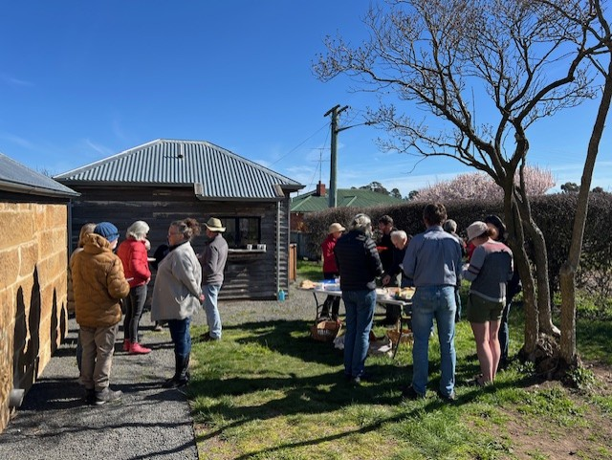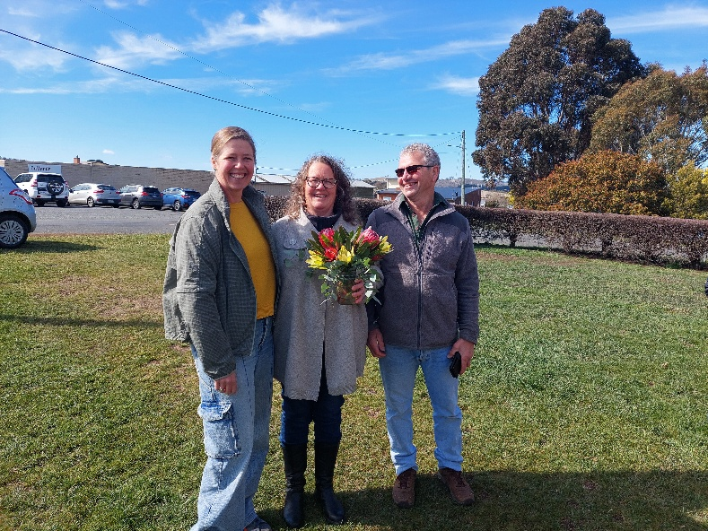
A delicious shared lunch was enjoyed by all out in the sunshine A big thank you to Jo Widdowson for the last 4 years

FRIENDS OF DEAL ISLAND NEWSLETTER 45 SPRING 2025

…East Cove Stabilisation project continues…
The past two working bees have recommenced efforts to revegetate the embankment above East Cove. This has consisted of
- Removing browsing pressure and animal track wear by securing the fenced enclosure and removing wallabies
- Propagating a mix of native plants to help hold the bank substrate, and compete against weeds
- Securing erosion control barriers across the slope where there is little to hold the soils.
While the works haven’t been in place for long, there are some encouraging signs that it is assisting with reestablishment of native vegetation.
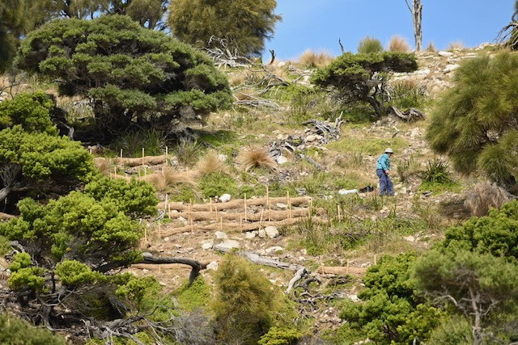
Sue Walker working on Stabilizing jute sausages March 2025
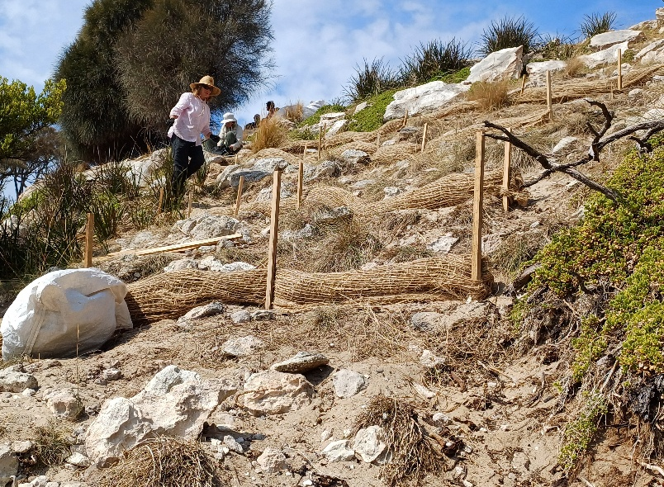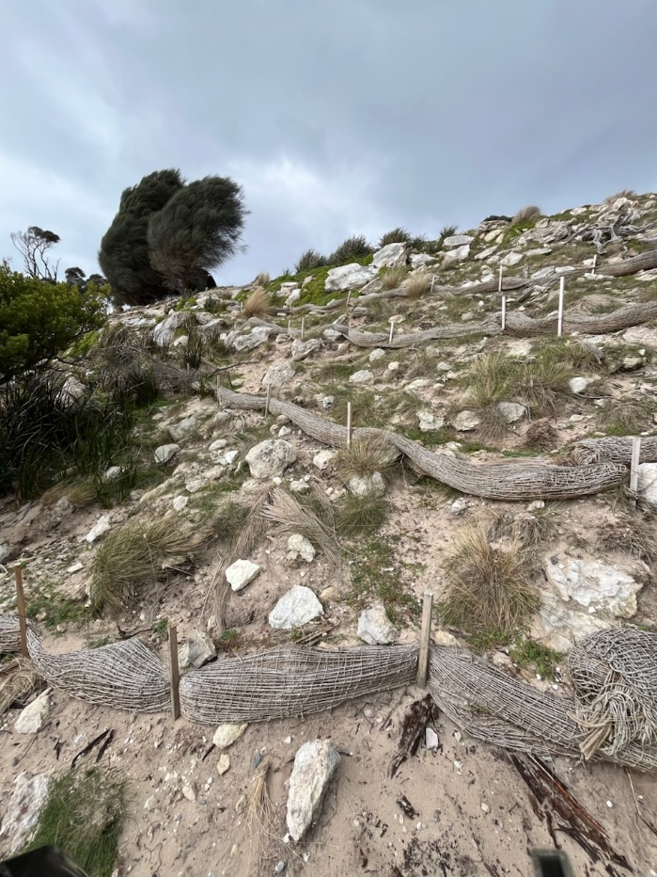
Georgie Dudgeon and others creating sausages March 2025 Same area August 2025
FRIENDS OF DEAL ISLAND NEWSLETTER 45 SPRING 2025

……..Caretaker Stories from 25 Years…….
The theme of the meeting was ‘celebration of the 25 years’ of the caretaker programe in its current form. Stuart relayed stories from David and Cheryl Quon who were caretakers for Bush Heritage in Aug /Sept 1999 & 2000. David and Cheryl saw a segment on Stateline with lots of arial footage about an island in the middle of Bass strait, and that Bush Heritage were looking for caretakers
They looked at each other and said” I’m keen if your keen”. They were asked could they go in two weeks, and so found themselves on a borrowed plane being flown with what they thought would be enough food for six weeks into northern Bass Strait. They found they were to sleep on a mattress on the floor without much other furniture, relying on mostly candles with only two hours generator power a day. They saw these as minor inconveniences when taking into account what the island had to offer them
Stuart Dudgeon recalled being given the role of finding caretakers to volunteer for 3 months on the island in Nov 2000. Some of the early caretakers were David and Trauti Reynolds… David was there to share some of his memories, of relying on the generator (was up to 4 hrs a day by then) to pump water for the shower. The hot water was gas and the pilot light was renowned for blowing out regularly during a shower, and the mysterious abandoned fishing boat that floated in and out of the passage for several days.
David Fletcher from Ballarat, Victoria was caretaking in 2008 with two friends and brought along a book of stunning images he had captured while there including one of a slightly derelict looking museum.
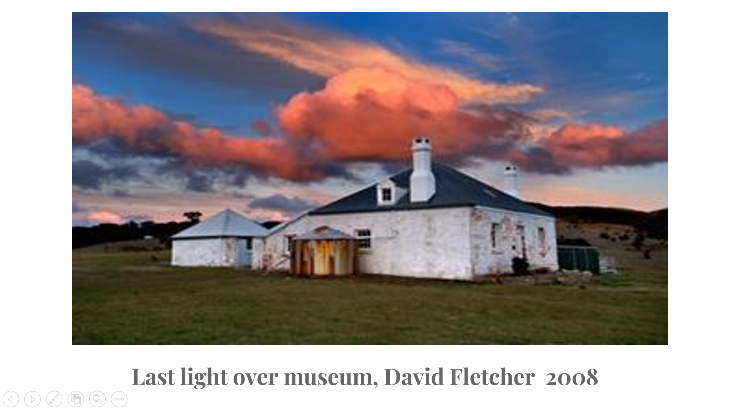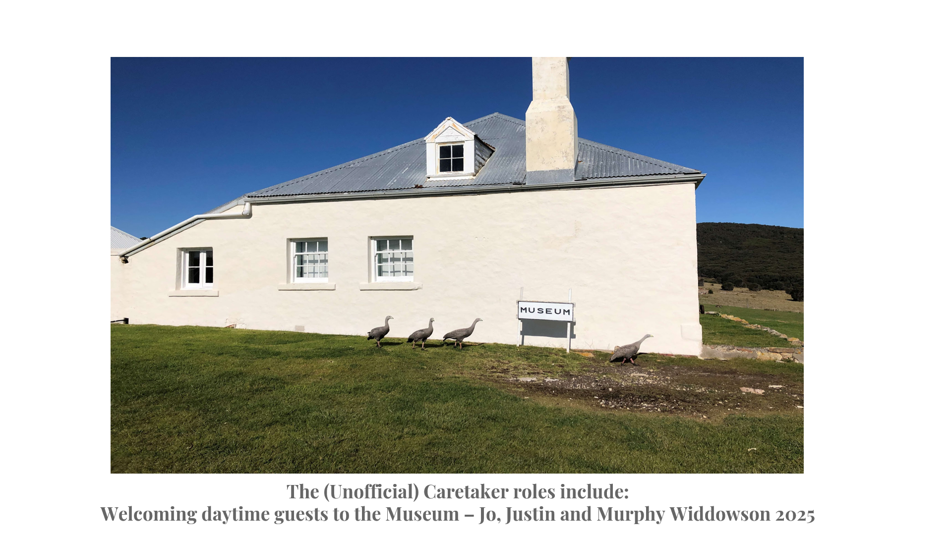
The Dudgeons reminisced about an overnight boating trip to the island including crossing Banks Strait in March 2003 during a forecast gale warning that proved to be spot on, with three young children. Once there, entertaining the children led to treasure hunts, guessing the rain, as well as many long walking adventures.
Jo Widdowson recalled her son Murphy loving jetty jumping, finding a new species of spider which was named after Murphy.
There were also photo contributions from Cathie Plowman and David Bulter who thoroughly enjoying working with the FODI working bee group, especially Shirley Fish who worked tirelessly while there. Stuart Baird and Mads Habib also contributed to the photos from their time on the island.

FRIENDS OF DEAL ISLAND NEWSLETTER 45 SPRING 2025

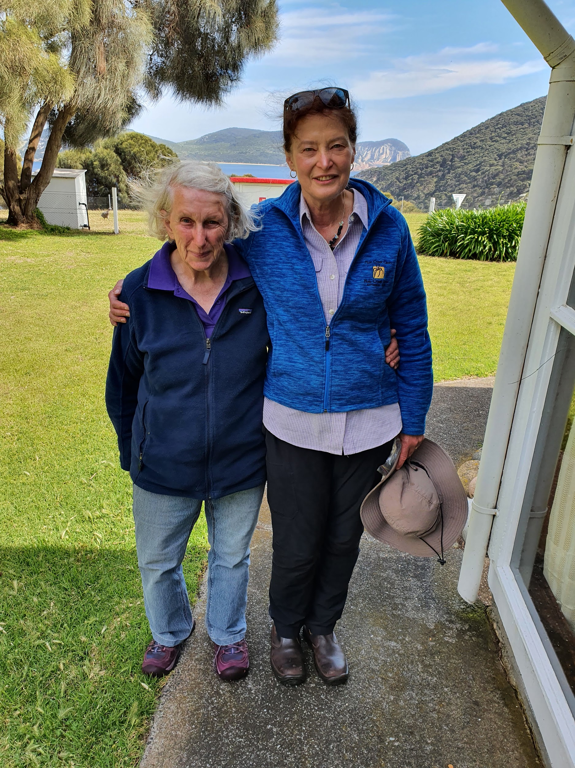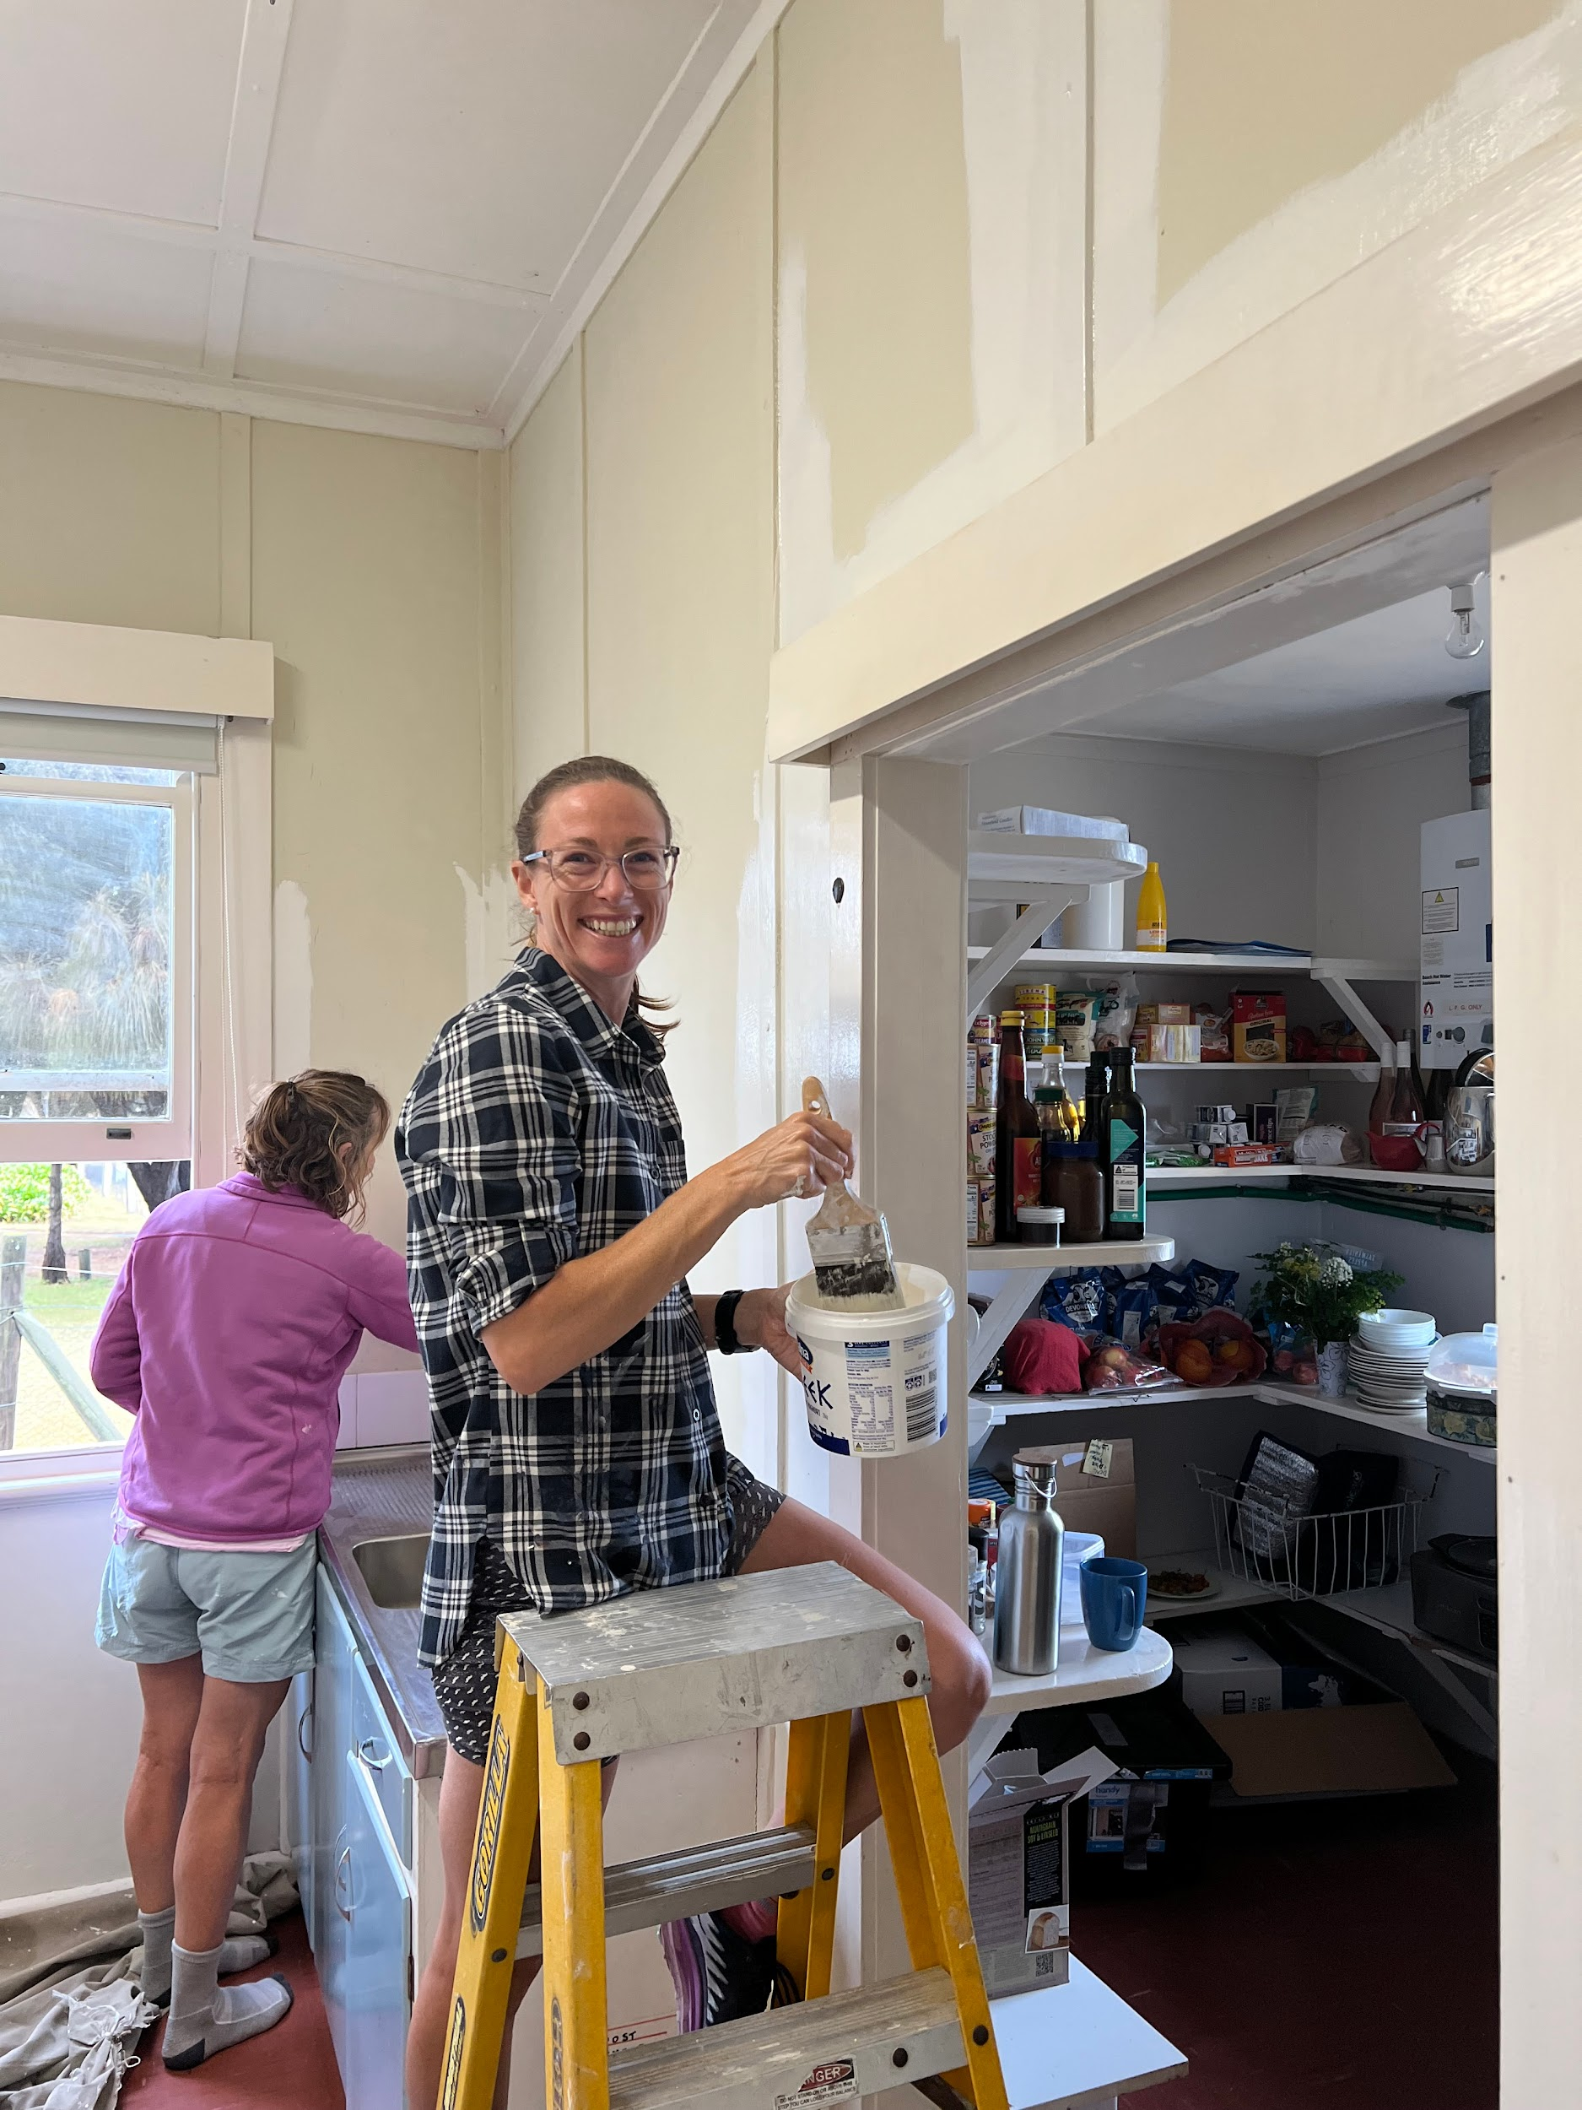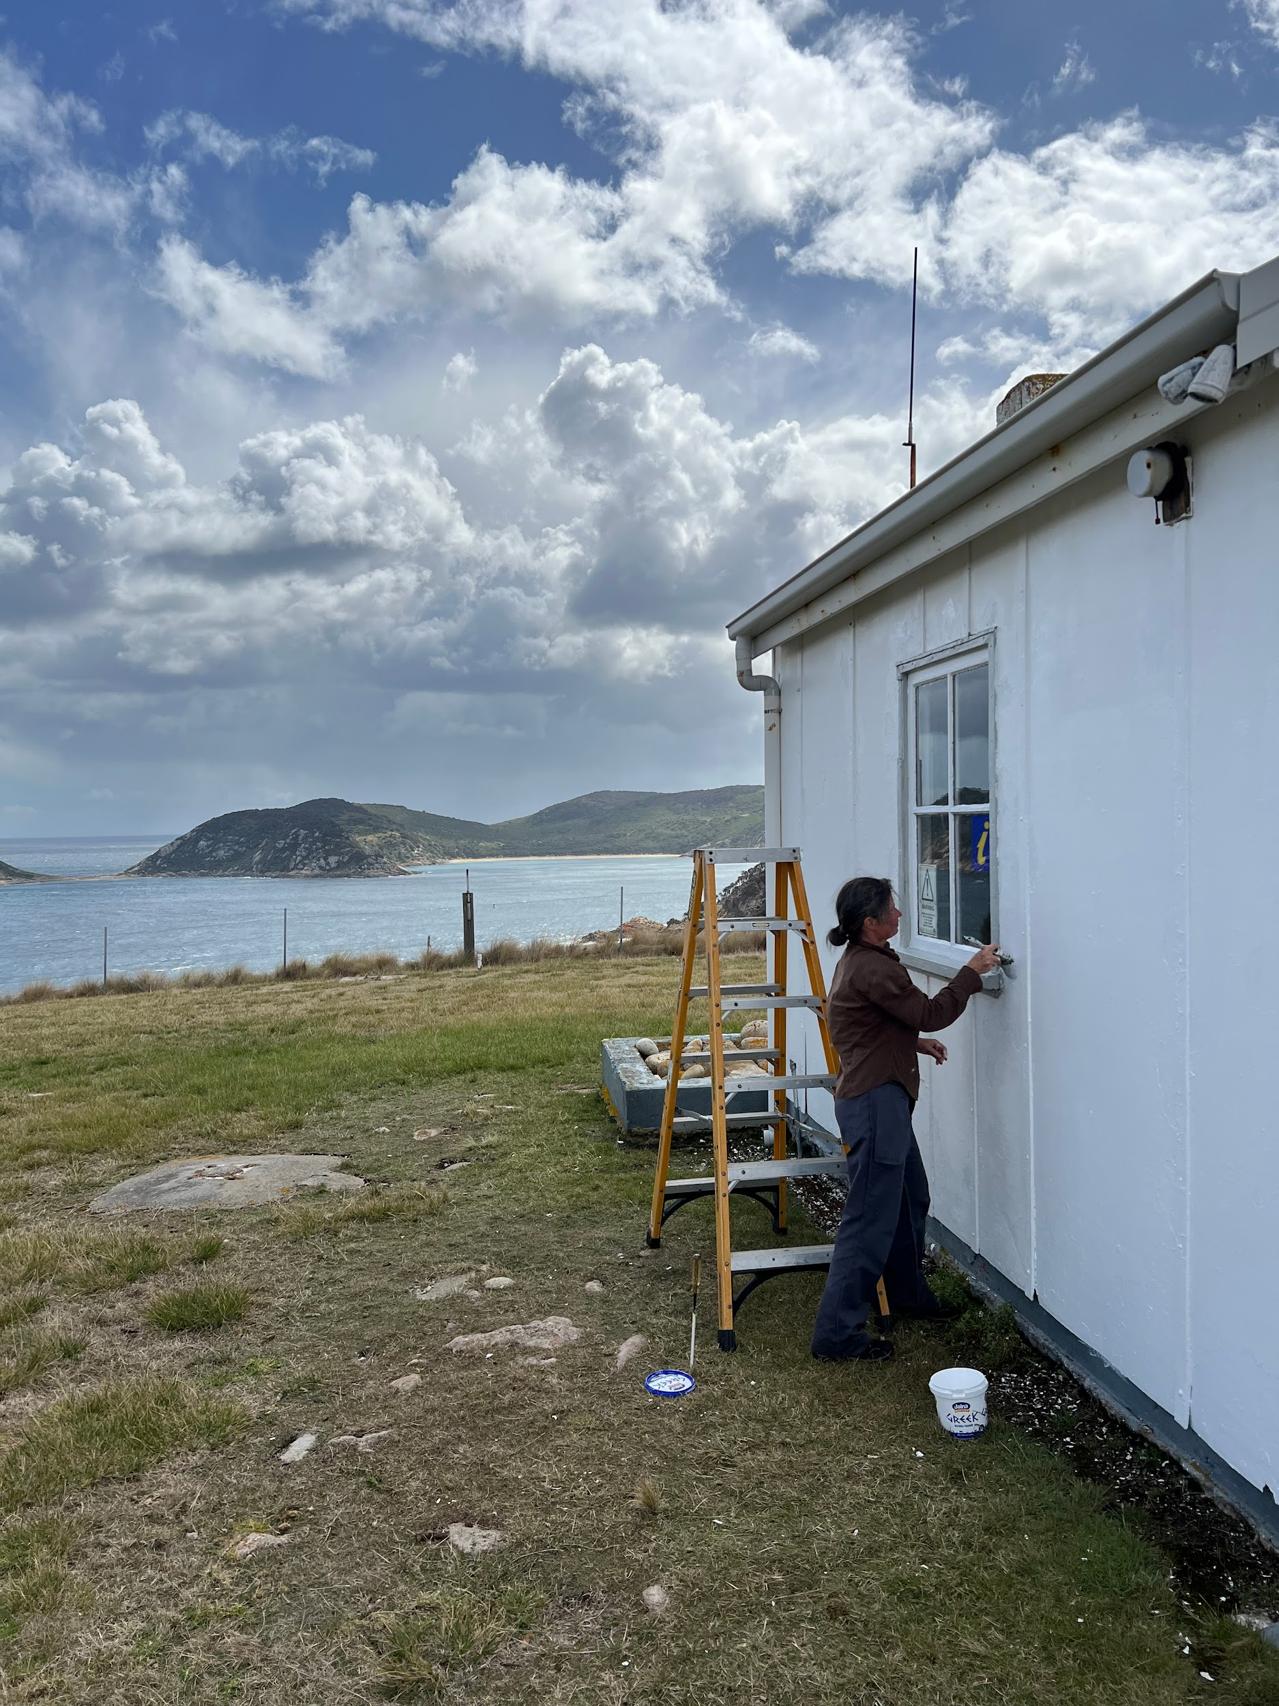
Cathie Plowman with long term Alana and Georgie painting visitors Cassie Strain tidying up the radio room
working bee stalwart Shirley Fish house kitchen

……..What’s coming up……..
The working bee in November is being led by Cassie Strain, with the major focus being on weed control, and propagating more plants for the March working bee to plant, maintenance on the existing East Cove bank stabilization works and plantings.
Weed focus is still on searching for and removing any Sea Spurge, Arum Lily & Horehound, while trying to limit the spread of Ragwort and Slender Thistles. As the numbers reduce for Sea Spurge, the need for thorough searching is becoming more important to ensure there is little or no new seeds produced.
The committee will be looking at a range of fundraising activities including raffle, grant applications and merchandising options.
There is also interest in from several committee members in recording caretakers’ stories from the last 25 years, which Gabrielle Balon is keen to take a lead in …So past Caretakers get in touch if you would like to contribute.
Kind Regards
FODI committee

